**Car Customization and Option Display**

Create a program that allows users to customize a car build and prints all the selected options. The user will provide input via standard input, and the output will be displayed on standard output.

***Code –***

import java.util.*;  
class Car{  
 String manufacturer,transmission,fueltype,color,location;  
 public Car(String manufacturer, String transmission, String fueltype, String color,String location){  
 this.manufacturer=manufacturer;  
 this.transmission=transmission;  
 this.fueltype=fueltype;  
 this.color=color;  
 this.location=location;  
 }  
 public void dis(){  
 System.*out*.println("Manufacturer: "+manufacturer);  
 System.*out*.println("Transmission: "+transmission);  
 System.*out*.println("Fuel Type: "+fueltype);  
 System.*out*.println("Color: "+color);  
 System.*out*.println("Location: "+location);  
 }  
}  
class Mahindra extends Car{  
 String model;  
 public Mahindra(String model, String transmission, String fueltype, String color,String location){  
 super("Mahindra",transmission,fueltype,color,location);  
 this.model=model;  
 }  
 public void dis(){  
 super.dis();  
 System.*out*.println("Model: "+model);  
 }  
}  
public class Carcus{  
 public static void main(String[] args){  
 Scanner sc = new Scanner(System.*in*);  
 System.*out*.println("Manufacturer (Mahindra/Tata.Maruti): ");  
 String manufacturer = sc.nextLine();  
 if(manufacturer.equalsIgnoreCase("Mahindra")){  
 System.*out*.println("Enter Model (Scorpio/Thar/Scorpio N/XUV300/XUV700: ");  
 String model = sc.nextLine();  
 System.*out*.println("Transmission (Manual/Automatic): ");  
 String transmission = sc.nextLine();  
 System.*out*.println("Fuel Type (Diesel/Petrol/CNG): ");  
 String fueltype = sc.nextLine();  
 System.*out*.println("Color (Silver/Blue/Yellow): ");  
 String color = sc.nextLine();  
 System.*out*.println("Location (Delhi/Bangalore/Hyderabad/Chennai): ");  
 String location = sc.nextLine();  
 Mahindra car = new Mahindra(model,transmission,fueltype,color,location);  
 car.dis();  
 }else{  
 System.*out*.println("Transmission (Manual/Automatic): ");  
 String transmission = sc.nextLine();  
 System.*out*.println("Fuel Type (Diesel/Petrol/CNG): ");  
 String fueltype = sc.nextLine();  
 System.*out*.println("Color (Silver/Blue/Yellow): ");  
 String color = sc.nextLine();  
 System.*out*.println("Location (Delhi/Bangalore/Hyderabad/Chennai): ");  
 String location = sc.nextLine();  
 Car car = new Car(manufacturer,transmission,fueltype,color,location);  
 car.dis();  
 }  
 }  
}

***Output –***

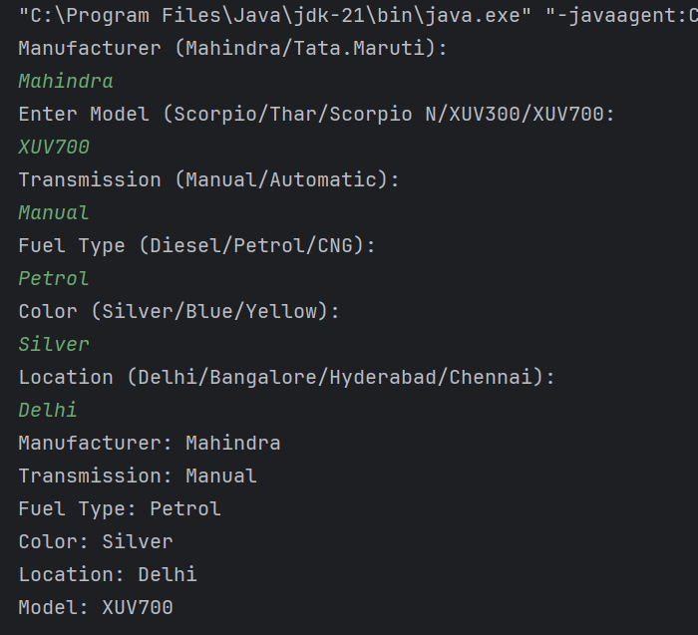

**Problem Statement: Tax Calculation**

Write a program to calculate the annual tax owed by an individual based on their salary, age, and other parameters. The user will input their details, and the program will output the total tax amount.

***Code –***

import java.util.*;  
  
class Taxp<T extends Number> {  
 T salary;  
 int age;  
 public Taxp(T salary, int age) {  
 this.salary = salary;  
 this.age = age;  
 }  
 public T getSalary() {  
 return salary;  
 }  
 public int getAge() {  
 return age;  
 }  
}  
  
class TaxCalculator<T extends Number> {  
 private Taxp<T> person;  
 private double investment, health, loan;  
 public TaxCalculator(Taxp<T> person, double investment, double health, double loan) {  
 this.person = person;  
 this.investment = Math.*min*(investment, 150000);  
 this.health = person.getAge() >= 60 ? Math.*min*(health, 50000) : Math.*min*(health, 25000);  
 this.loan = Math.*min*(loan, 200000);  
 }  
  
 public double calculateTax() {  
 double totalDeduction = investment + health + loan;  
 double income = person.getSalary().doubleValue() - totalDeduction;  
 int age = person.getAge();  
 double tax = 0;  
 if (age < 60) {  
 if (income > 250000) {  
 tax += Math.*min*(income - 250000, 250000) * 0.05;  
 if (income > 500000)  
 tax += Math.*min*(income - 500000, 500000) * 0.20;  
 if (income > 1000000)  
 tax += (income - 1000000) * 0.30;  
 }  
 } else if (age < 80) {  
 if (income > 300000) {  
 tax += Math.*min*(income - 300000, 200000) * 0.05;  
 if (income > 500000)  
 tax += Math.*min*(income - 500000, 500000) * 0.20;  
 if (income > 1000000)  
 tax += (income - 1000000) * 0.30;  
 }  
 } else {  
 if (income > 500000) {  
 tax += Math.*min*(income - 500000, 500000) * 0.20;  
 if (income > 1000000)  
 tax += (income - 1000000) * 0.30;  
 }  
 }  
 return tax;  
 }  
}  
  
public class Tax {  
 public static void main(String[] args) {  
 Scanner sc = new Scanner(System.*in*);  
 System.*out*.print("Annual Salary: ");  
 double salary = sc.nextDouble();  
 System.*out*.print("Age: ");  
 int age = sc.nextInt();  
 System.*out*.print("Investment in Tax-saving instruments: ");  
 double investment = sc.nextDouble();  
 System.*out*.print("Health Insurance Premium: ");  
 double health = sc.nextDouble();  
 System.*out*.print("Home Loan Interest: ");  
 double loan = sc.nextDouble();  
 Taxp<Double> person = new Taxp<>(salary, age);  
 TaxCalculator<Double> calculator = new TaxCalculator<>(person, investment, health, loan);  
 double tax = calculator.calculateTax();  
 System.*out*.printf("Total Tax Owed: %.2f\n", tax);  
 }  
}

***Output –***

